PRACTICE QUESTIONS FOR FIRST TWO CLASSES

To open a new worksheet to write your queries
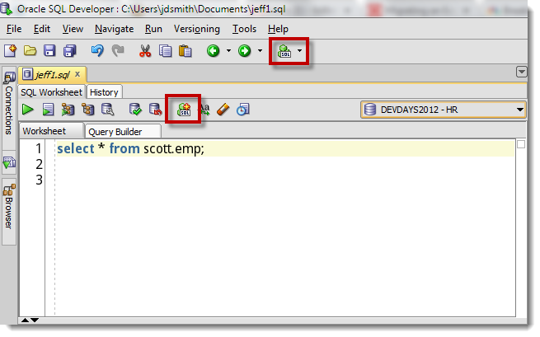
When exiting out of your sql developer you can have the option to save the worksheet so when you come back in any queries that were there will remain there.

Please provide your queries for the questions below. You can always refer to google ot W3schools for sql online

1)Provide a count for each table existing in the DB.

2)Provide all the customers first name, last name, and email from appropriate table

3)Which customer has the smallest customer_id? How would you find this?

4)Provide the minimum price, maximum price, and the average price for products.

5)Provide average list price of products for category id =1.

6)Provide minimum price of products for products whose category id = 2 and sort by product name smallest to largest.

7)Provide a count of products in category id=3;

8)Provide a count of products in each of the categories. Provide extra queries to prove this.

9)Select all orders with status pending for customer id=2

10)Select all orders with status pending for customer ids 1,2, and 3. Provide me with two ways of doing this.

Hint: need to use AND along with multiple OR conditions

Note: Oracle SQL Developer is case sensitive
11)Provide all warehouse information where the warehouse name starts with S.

12)Provide all warehouse information where the warehouse name ends with y.

13)Are there any category_ids that exist in product_categories that are not assigned to any products in the category table?
Hint: Use subquery and NOT IN

14)INSERT a new record into contacts with your information.
Validate that this worked.

15)Update the last name for the record you created to 'Khan'. NOTE: First do a select so you have your where clause for the update. If you update all records, it will effect the SHARED db. If you do end up making a mistake just reach out to me and I will reset the table. No worries.

16)Give me the first name, last name for all customers whose customer id is between 5 and 10 (inclusive)

17)Give me all products whose standard cost is less than 100
same as asking how many products cost us less than 100?)

https://www.w3schools.com/sql/sql_where.asp
Hint: use > greater than, < for less than, = for equal, >= for greater than or equal to , <= less than or equal to ex. Price>100 means price is greater than 100.

18)give me the average list price of our product if the products is great than 100.
19)give me the average list price of our product if the product is less than 100

20) list all products whose category id is 5 or 4 and sort it based on cost from greatest to largest

